AL-FARABI KAZAKH NATIONAL UNIVERSITY | 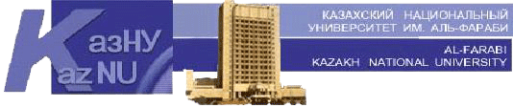

Faculty of Philology and World Languages

Confirmed by
Dean of the faculty
______________ B.U.Dzholdasbekova
№ __, ________ __, 20__

Methodical recommendations for the preparation of EMCD:
“Map of educational and methodical supply of the discipline”

Discipline: Foreign language for professional purposes
Course/Specialty 3course
Semester 6

№ | Textbooks and tutorials | Internet Resources | Quantity in the library | % of sufficiency
1. | Inside Reading 1, Oxford University press, Arline Burgmeier,2009. | + |  | 100%
2. | Raymond Murphy. English Grammar in Use. Third edition. Intermediate Level. – Cambridge: Cambridge University Press, 2013 | + |  | 100%
3. | Inside Reading 2, Oxford University press, Lawrence J.Zwier,2009. | + |  | 100%
4. | McCarthy M., O’Dell F. English Vocabulary in Use. New edition. Upper-Intermediate. – Cambridge: Cambridge University Press, 2012 | + |  | 100%
5.

Considered and recommended at the meeting of the Department of General Linguistics and European Languages
Protocol № __, ________ __, 20__
Head of the department _____________________ G.B. Madiyeva

Confirmed by methodical bureau of the faculty
Protocol № __, ________ __, 20__

Chairman ________________________ L.V. Ekshembeeva

